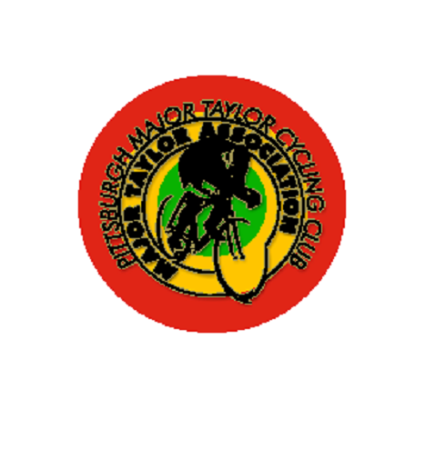

Pittsburgh Major Taylor Cycling Club Sponsorship Form

The mission of the Pittsburgh Major Taylor Cycling Club is to introduce cycling, develop skills, provide instruction, and to promote overall health benefits to the Pittsburgh community, particularly targeting those communities disproportionately affected by health issues. We are a non-profit organization dedicated to bicycling. The Club’s focuses is to provide the novice, intermediate, and advanced cyclist the opportunity to ride, train, and socialize with other cycling enthusiasts.

The Pittsburgh Major Taylor Cycling Club (PMTCC) would like to offer you the opportunity to promote your business by providing sponsorship. This sponsorship entitles you to have your logo or business name to be displayed on our website, social media, and any event flyers for that year.

The minimum donation for sponsorship is $250, but additional donations over this amount are being accepted.

Check #___________ Amount of check$ __________________
OR
submit payment via Paypal majortaylorpittsburgh@gmail.com

Contact Name ____________________________ ______Phone Number _________________________

Contact Signature ______________________________

Address ________________________________ City ___________________ State _____ Zip _________

Please make checks payable to:
Pittsburgh Major Taylor Cycling Club
P.O. Box 24094
Pittsburgh, PA 15206-4055

A letter acknowledging your sponsorship will be mailed to you after payment is received.

If you have any questions, please do not hesitate to contact Shay Bailey, President at smileydeucepoint0@gmail.com

